Tier Menu

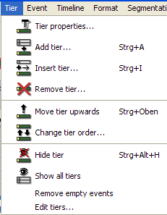

Most of the functions in the tier menu are only accessible once you have marked a tier. In order to select a tier, click on the corresponding speaker label at the beginning of the tier:

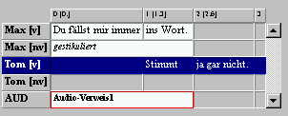

Tier > Tier properties…
Opens a dialog that allows editing properties of the currently selected tier.

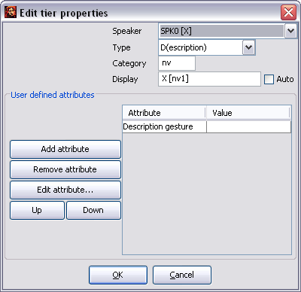
Four attributes are defined:
- Speaker: the assigned speaker. All defined speakers are listed as options in the ComboBox. If it is not useful to assign the tier in question to a speaker, choose "no speaker“.
- Type: the tier type. Choose "T(ranscritpion)“ for verbal tiers, "D(escription)“ for nonverbal tiers, "A(nnotation)“ for tiers with annotations (translations etc.), "L(ink)“ for tiers that contain links to files and "U(ser) D(efined)“ for other tiers. The correct assignment of the tier type is especially important for segmentation functions.
- Category: the tier category. It can be defined freely or remain empty. A category should be defined, if you set up more than one tier for a speaker. For example, enter "v“ for "verbal“, "nv“ for "nonverbal“, "c“ for "comment“ or "ENG“ for an "English Translation“.
- Display: the name of the tier that should be used for the tier for the output in the Partitur-Editor. If the option "Auto“ is activated, this name is automatically generated from the abbreviation and the category. In order to enter a different tier name, deactivate the option "Auto“ and enter the desired name.

"User defined attributes“ allows the additional input of user-defined attribute-value pairs for the tier (for a manual, see "File > Edit Meta Information“).

Tier > Add tier…
(Shortcut: CTRL+A on Windows, ⌘+A on Mac)

Opens a dialog to add a new tier at the end of the transcription.

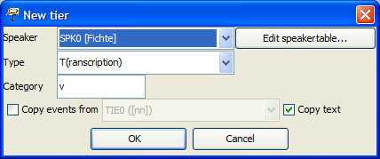

The entries under "Speaker“, "Type“ and "Category“ are equivalent to the ones described above in "Tier > Edit tier properties...“. If the option "Copy events from“ is selected, empty events will be inserted into the new tier, wherever the copied tier also contains entries (this can be especially useful for annotation tiers).

Tier > Insert tier…
(Shortcut: CTRL+I on Windows, ⌘+I on Mac)

Opens a dialog to insert a new tier above the currently selected tier. The dialog is identical to the "Tier > Add tier...“ dialog described above.

Tier > Remove tier…
Removes the currently selected tier. A confirmation prompt is then carried out. In order to hide a tier, rather than deleting it permanently, use "Tier > Hide tier“.

Tier > Move tier upwards…
(Shortcut: Ctrl +  on Windows, ⌘ +  on Mac)

Moves the currently selected tier upwards.

Tier > Change tier order…
Opens a dialog that allows changing the tier order:

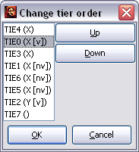

Select the tier that you would like to move, click Move up to move it up or Move down, to move it down. In order to save the changes made, close the dialog by clicking OK .

Tier > Hide tier
Hides the currently selected tier.

Tier > Show all tiers
Shows all hidden tiers again.

Tier > Remove empty events
Removes empty events, hence events that only contain spaces, from the currently selected tier.

Tier > Edit tiers…
Opens a dialog that contains an overview of all properties of all tiers and allows these to be changed.

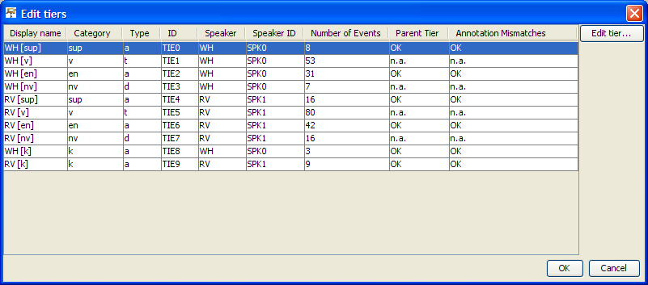

Shown from left to right are:
- Display Name: the name that is displayed in the musical score at the beginning of every tier
- Category: the tier category
- Type: the tier type
- ID: the ID tier assigned by the program
- Speaker: the speaker abbreviation assigned to the speaker
- Speaker ID: the speaker ID assigned by the program
- Number of Events: the number of events within this tier
- Parent Tier: for tiers of the type 'A(nnotation)' the software checks, whether a tier of the type 'T(ranscription)' that is linked to the same speaker exists. If this is the case, an "OK" will appear, otherwise "#Error". For tiers of type 'T(ranscription)' or 'D(escription)', "n.a." for "not applicable" is displayed.
- Annotation mismatches: for tiers of the type 'A(nnotation)', the software checks whether all events have a corresponding event in the respective tier of type 'T(ranscription)' (see also "Transcription > Structure errors"). If this is the case, "OK" will appear, otherwise the number of faulty annotations will be shown. For tiers of type 'T(ranscription)' or 'D(escription)', "n.a." for "not applicable" is displayed.

Event Menu

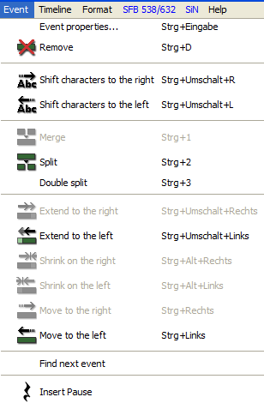

Event > Event properties…
(Shortcut: CTRL + Enter on Windows, ⌘ + Enter on Mac, as well as by right clicking into the corresponding event)

Opens a dialog to edit the currently selected event:

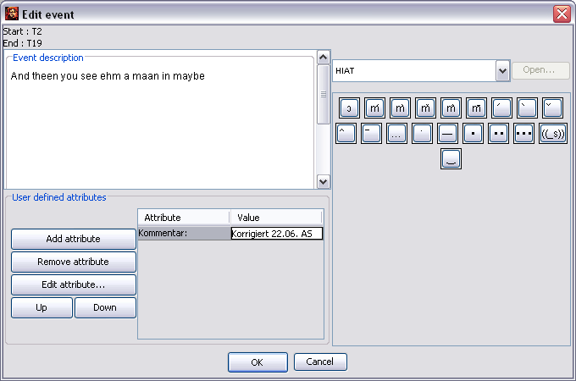

The event text can be edited via "Event description“ – this may be of convenience especially when writing extensive descriptions. "User defined attributes“ allows the entry of user defined attribute-value pairs for the event (how to operate this field can be found under "File > Meta information“).

Event > Remove
(Shortcut: CTRL+D on Windows, ⌘+D on Mac)

Removes the currently selected event.

Before:
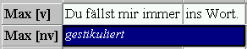

After:
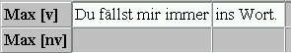

Event > Shift characters to the right
(Shortcut: CTRL +  + R on Windows, ⌘ +  + R on Mac)

Shifts the characters to the right of the current cursor position into the next event.

Before:
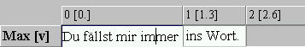

After:
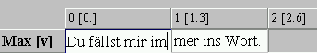

Event > Shift characters to the left
(Shortcut: CTRL +  + L on Windows, ⌘ +  + L on Mac)

Shifts the characters to the left of the current cursor position into the previous event.

Before:

After:

Event > Merge
(Shortcut: CTRL + 1 on Windows, ⌘ + 1on Mac)

Merged two or more selected events in a tier into one event.

Before:
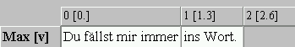

Select:
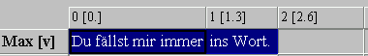

After:
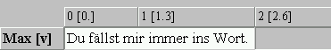

Event > Split
(Shortcut: CTRL + 2 on Windows, ⌘ + 2on Mac)

Splits the current event into two at the cursor position.

Before:
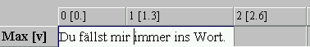

After:
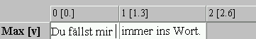

If the current event only includes a time span from one time point to the next, a new time point will be inserted on the time axis.

If the event has a time span from one time point up to two time points thereafter, like in the example, it will be split at the interjacent time point.

If the time span is greater, a dialog will open in which the time point at which the event is to be split can be selected:

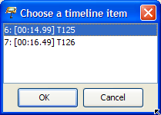

Event > Double split
(Shortcut: CTRL + 3 on Windows, ⌘ + 3on Mac)

Splits the current event according to the current text selection in three events.

Before:
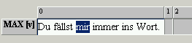

After:
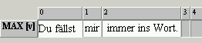

If the event in question covers more than one time interval this function is deactivated. In this case apply the function Event > Split Event twice.

Event > Extend to the right
(Shortcut: CTRL +  + on Windows, ⌘ + +on Mac)

Extends the currently selected event to the right by one time point.

Before:
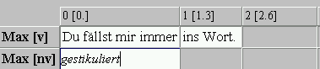

After:
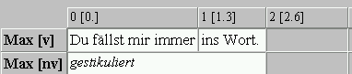

Event > Extend to the left
(Shortcut: CTRL +  + on Windows, ⌘ + +on Mac)

Extends the currently selected event to the left by one time point.

Event > Shrink on the right
(Shortcut: CTRL + Alt +  on Windows, ⌘ + Alt+  on Mac)

Shrinks the currently selected event by one time point from the right.

Before:

After:

Event > Shrink on the left
(Shortcut: CTRL + Alt +  on Windows, ⌘ + Alt+  on Mac)

Shrinks the currently selected event by one time point from the left.

Event > Move to the right
(Shortcut: CTRL +  on Windows, ⌘ +  on Mac)

Moves the currently selected event to the right by one time point.

Before:
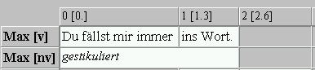

After:
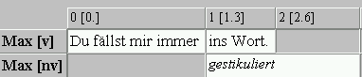

Event > Move to the left
(Shortcut: CTRL +  on Windows, ⌘ +  on Mac)

Moves the currently selected event to the left by one time point.

Event > Find next event
Looks for the next event in the tier that is currently active from position of the current selection.

Event > Insert Pause
Inserts a pause into the selected event with the length of the current selection in the oscillogram. The specific notation of the pause can be set via “Edit > Preferences > Segmentation”.

